Reference Sheet

Entering Your Class
- Enter your username and password at http://hs.saplinglearning.com and press “Go”
  - Do NOT try to log in at www.saplinglearning.com. You must use the high school site.
- From the main page, click the name of your class near the middle of the page.
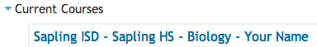
Your Course will have your district and your school name followed by your teacher’s name.
Class Overview
- Your grade will be dependent on how well you do on assignments. These are sets of questions indicated by a green leaf () next to their title. If a due date has been set, this will display next to the title.
  - Assignments with an upcoming due date are found in the top right corner of the page.
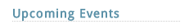
- Resources (files your teacher has uploaded) are found in the white area in the middle of the page. An icon () beside their title indicates a resource.
- If enabled, forums () allow you to chat with other students or teachers.

Inside Activities (click a green leaf to enter an activity)
Note that your teacher may disable some of these features on certain assignments.
You will probably want to watch the Video Introduction to Sapling Learning
- Creates a PDF of the activity to save on a USB drive or print.
- Allows you to move to different questions in the assignment.
- Grades the question and provides feedback.
- Returns you to your course. Your grade so far will be saved.
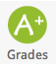
Grade Book
- You can see your personal grades at any time by clicking the grades icon in the left.

Username and Password
- Keep your login information in a safe and secure place. Your grade in class will be dependent on your Sapling Learning grades. Always log out when finished working on your assignments.
- If you forget your username and/or password, let your teacher know as soon as possible. They can reset it for you.

