Students’ First Day

Throughout the school year, you are responsible for logging into Sapling Learning to get notes, presentations, and complete homework assignments. If not, your grade may be affected. As you work problems, you will be receiving feedback to help you learn. You can print your assignments and work on them offline, but make sure to enter your answers online before the due date passes.

Changing Your Name
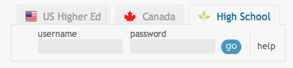
- Please login at http://hs.saplinglearning.com with the username and password provided by your teacher.
  - Note: you will not be able to login at http://www.saplinglearning.com unless you click the “High School” tab on the top right of the webpage.
- After you log in, click your current generic name in the top right.
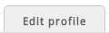
- On this page, click the tab labeled “Edit profile”
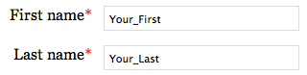
- Replace the generics with your real first name and last name.

- Type in your student ID number if you have one.

- Press the “Update profile” button at the bottom.
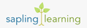
- Return to the main page by clicking “Sapling Learning” in the top left.

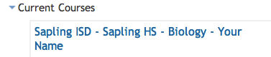
Entering Your Class
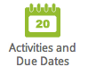
- From the main page, click the name of your class near the middle of the page. It will look similar to this.

- Assignments with an upcoming due date are found in the top right corner of the page.

- Files your teacher has uploaded are found throughout the white area in the middle of the page.
- For student help, click the link to the student FAQ page.

