Maxwell’s Equations

Gauss' Law for Electricity
The electric flux out of any closed surface is proportional to the total charge enclosed within the surface.
The integral form of Gauss' Law finds application in calculating electric fieldsaround charged objects.

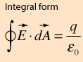

Gauss' Law for Magnetism
The net magnetic flux out of any closed surface is zero. This amounts to a statement about the sources of magnetic field. For a magnetic dipole, any closed surface the magnetic flux directed inward toward the south pole will equal the flux outward from the north pole. The net flux will always be zero for dipole sources. If there were a magnetic monopole source, this would give a non-zero area integral.
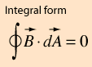

Faraday's Law of Induction
The line integral of the electric field around a closed loop is equal to the negative of the rate of change of the magnetic flux through the area enclosed by the loop.
This line integral is equal to the generated voltageor emf in the loop, so Faraday's law is the basis for electric generators. It also forms the basis forinductors and transformers.
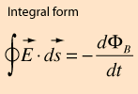

Ampere's Law
In the case of static electric field, theline integral of the magnetic fieldaround a closed loop is proportional to the electric current flowing through the loop. This is useful for the calculation of magnetic field for simple geometries.
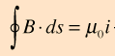

Also for an LC circuit the frequency is related by

2*pi*f = 1/(sqrt(LC)

