CIRCULAR-GRAVITATION EXTRA PRACTICE

1.
2.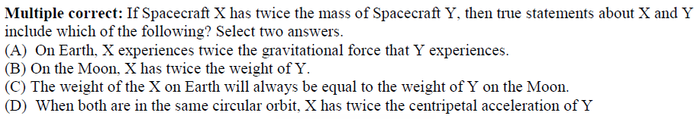
3.
4.

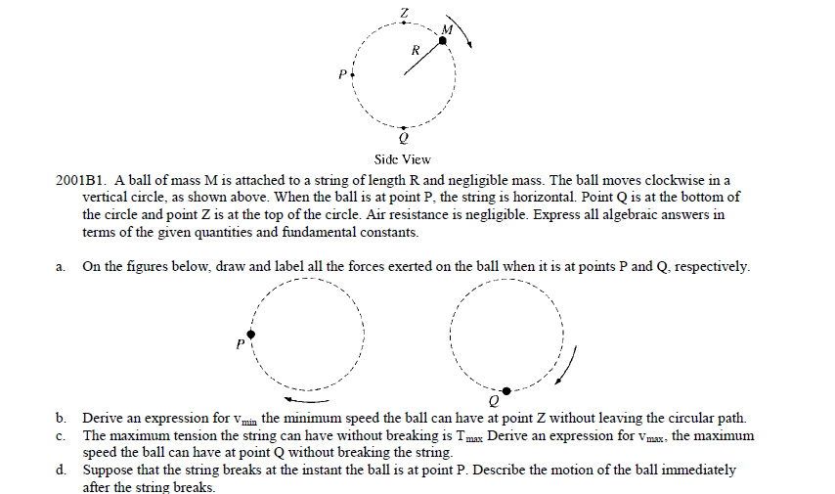
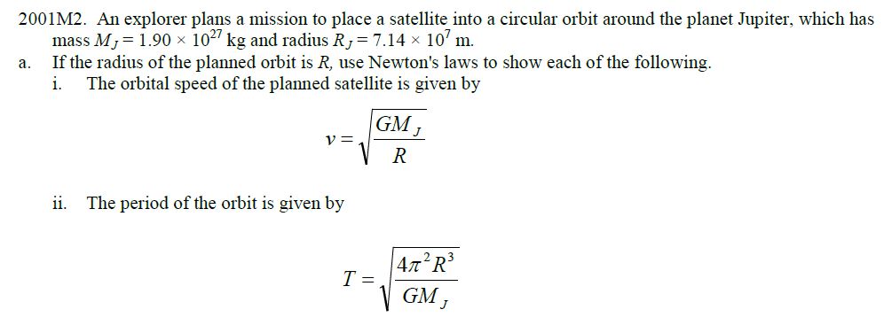

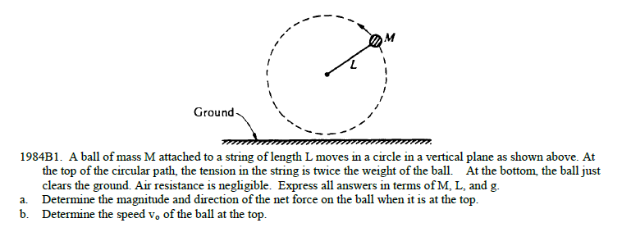

Multiple Choice Answers. 1) D 2) A,B 3) B 4) B
